Table of Contents
1. Project framework 5
1.1 Introduction 5
1.2 All Around the World enterprise “AAW” 6
1.2.1 AAW Presentation and service 6
1.3 Open source VS closed source 6
1.3.1 Open source 6
1.3.2 Closed source 6
1.3.3 Difference between open source and closed source 7
1.4.1 Agile method 7
2 Project scope 9
2.1 Introduction 9
2.2 Analysis of existing requirement tools 9
2.2.1 Commercial tools 9
2.2.2 In house tools 11
2.2.3 Open source tools 12
2.3 scoping processing 13
2.3.1 Business process analysis 13
2.3.2 Functionality process analysis 14
2.3.3 Business process analysis tools 15
2.3.4 Technology analysis 16
2.3.5 Benefits analysis 16
2.4 Requirement management 16
2.4.1 Introduction 16
2.4.2 Search 18
2.4.3 Elicitation 23
2.4.4 Gathering 32
2.4.5 Analysis 35
2.4.6 Validation / Verification 35
2.4.7 Categorization 36
2.4.8 De-duplication 37
2.5 Collaboration 37
2.6 User right management 37
2.7 Version control 37
2.8 Visualization 40
2.9 Synchronization UI-s 40
3 Design 40
3.1 Concept 40
3.1.1 Introduction 40
3.1.2 On-line work 40
3.1.3 Off-line work 40
3.1.4 Conclusion 40
3.2 Use cases 40
3.3 Data base format/Entry form 40
3.4 Setting up 40
3.4.1 Users 40
3.4.2 Crowd sourcing 40
3.4.3 Development environment 40
3.5 Data structure 40
4 Development 40
4.1 Use languages 40
4.2 NodeJS 40
4.3 Html5 41
4.4 jQuery 42

1. Project framework

1.1 Introduction
- Main objective:
The project is going to be used by the engineers of the company to cooperate in the management of specifications. It is written in several languages “NodeJS, HTML5, MySQL, Perl5 …”, the target medium of this project is LINUX. The project is used in a console “Terminal, middle prefer by the engineer” and also in a graphical interface for non-technical users. Documentation for the user will also be developed.
- Nature:
The project consists of the development of interfaces specific to the type of the user. Interfacing with an application of existing specifications in the company. Improved the existing application.
- Targeted audience:
The project targets the following audience.
  - Engineers of the company.
    - Engineers use a distributed development model.
  - Product management.
  - The marketing group.
    - Non-technical group.
  - The users.
- Content description:
  - Collection of user requests.
  - Development of interfaces specific to the type of the users.
  - Analysis of the applications of management of specifications present in the company.
  - Study of the market of applications of management of specification.
  - Analysis of the methods used for the processing of specification in the company.
  - Study of the research on the specification, particularly “Requirement crowd sourcing”.
  - Proposal for improvement for the application of the load management.
  - Implementation of proposals accepted by the company.
  - Test as part of an existing project containing a large number of loads.

1.2 All Around the World enterprise “AAW”

1.2.1 AAW Presentation and service

1.3 Open source VS closed source

1.3.1 Open source
Open source software “OSS” is computer software with its source code made available with a license in which the copyright holder provides the rights to study, change and distribute the software to anyone and for any purpose. Open source software may be developed in a collaborative public manner. Open source software is the most prominent example of open source development and often compared to “technically defined” user-generated content or “legally defined” open-content movements.[7],[8]
Example: “Linux, Mozilla Firefox, Java, MySql ...”

1.3.2 Closed source
Closed source software or “proprietary” is a type of computer program source code development. With closed source software, the source code is not shared with the public for anyone to look or make changes to. Closed source is the opposite of open source.[9]
Example: “Windows, Microsoft office, IOS ...”

1.3.3 Difference between open source and closed source
CLOSED SOURCE SOFTWARE | OPEN SOURCE SOFTWARE
Protected by copyrights, sold to earn money. | Software is distributed free of cost
Development is centralized, undertaken by expert developers. | Any individual can develop or modify the software.
Quality assurance and bug removal is done by small team. | Huge no. of individuals are available for improving quality and bug removal.
Software requirements are finalized by organization itself. | User can modify or develop a software as per his own needs.
Formal risk assessment process – monitored and managed throughout project. | No formal risk assessment process.

1.4 Sources and methods

1.4.1 Agile method
Agile software development is a group of software development methods in which solutions evolve through collaboration between self-organizing, cross-functional teams. It promotes adaptive planning, evolutionary development, early delivery, continuous improvement, and encourages rapid flexible response to change.
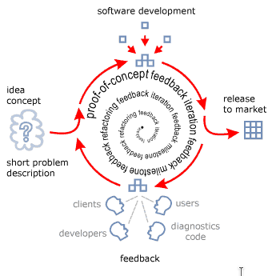

To consistently help our clients achieve the results they want, we employ an agile methodology for building and maintaining hight-quality software products. This process has proven itself in numerous successful releases to the market.[10],[11]
Methodology benefits.
- Faster development time.
- Lower overall cost.
- Focus on the right solution.
- A minimum of your time.
Steps to software success. “AAW”
- We brainstorm with you to understand your goals for the software.
- We create an initial “proof of concept” prototype.
- We evolve and adjust the prototype through multiple iterations in a series of milestones based on feedback from you and other stakeholders.
- We get closer to your final goals with each iteration and milestone.
- We re-factor the code and architecture throughout the entire life-cycle of the project to improve and streamline internal structure.
- We make you part of the development team through short brainstorming sessions – along with using and testing the evolving prototype – without taking up too much of your time.
- We deliver a final core software product that meets your highest expectations, along with your schedule.

2 Project scope

2.1 Introduction
This part is the result of an existing requirements tools “commercial or in house”. That’s why we will ameliorate an existing application in the company. Because we found a lot of problems since the engineer start working with it. First thing we will try to fix the missing functionality in the application, second thing we will try to make the application more fast, besides we will create a new two ways of requirement search to make it easy in use and we will create global data base. Also we will try to avoid what the commercial tools did it.

2.2 Analysis of existing requirement tools

2.2.1 Commercial tools
- RequisitePro “IBM”
Software delivery organizations must ensure that requirements from IBM Rational RequisitePro are integrated into the tools used by different stakeholders. Today, requirements are defined, reviewed, worked on and tested by various groups. This has led organizations to create complex workflows, processes, and documents, which can slow development and increase costs.
Tasktop addresses this by allowing requirements to be synchronized from RequisitePro to the rest of your software delivery tools. So you can flow requirements from one tool to another with no need for users to create reports, run extracts or attend meetings.
Requirements are synchronized in real-time, stakeholders can review them in the context of their own tool, and everyone in the software delivery process is kept abreast of the latest comments or changes.[6]
- Innoslate
Innoslate is a modern web-based systems engineering tool. This cloud or on-premise application was made specifically for systems engineers by systems engineers.
Innoslate provides the first modern systems engineering tool that supports the full life-cycle from Requirements Definition and Management to Operations and Support.
Innoslate takes the next step in software as a service implementation of new and classic systems engineering principles and practices to address today's and future systems of system level problems.
Innoslate provides a secure, transparent, and automatically upgraded environment to reduce IT costs and enhance collaboration on small and large problems.[5]
- DOORS
DOORS is part of a commercial suite of requirements management software produced by Telelogic. It is designed to manage large sets of requirements; large projects can have requirements that number in the thousands, with hundreds of users.
DOORS also supports concurrent and remote access by many users at once. There are many commercial software packages that offer requirements management functionality; Telelogic DOORS is one of the market leaders.
The aim of DOORS is to capture, link, trace, analyze and manage changes to information to ensure a project’s compliance with specified requirements and standards.[3],[4]
- Visure
Visure define requirements definition and management as a global set of different activities where requirements specification and subsequent management thereof are not sufficient and other activities are required, such as requirements capture, analysis, verification and validation, without forgetting to carry out adequate change configuration and control management, in addition to the traceability of the requirements to the rest of the project elements.[14]
Visure not only helps its clients to expedite the requirements definition and management implementation process but also to use and manage it, through the use of different mechanisms and training, evaluation and specialized consulting activities.

2.2.2 In house tools
This part is a presentation of an existing application in the enterprise developed by a group of engineers. This module implements a set of applications that the user can use it to do easy requirement handling that we have defined.
So there is a few of goals of the application to help us make the requirement handling ‘easy’.
- Keep things us simple if possible.
- The user interface provided by your platform.
- Power users like the command line.
- Handle small to middle size projects. ‘which are the most comman’
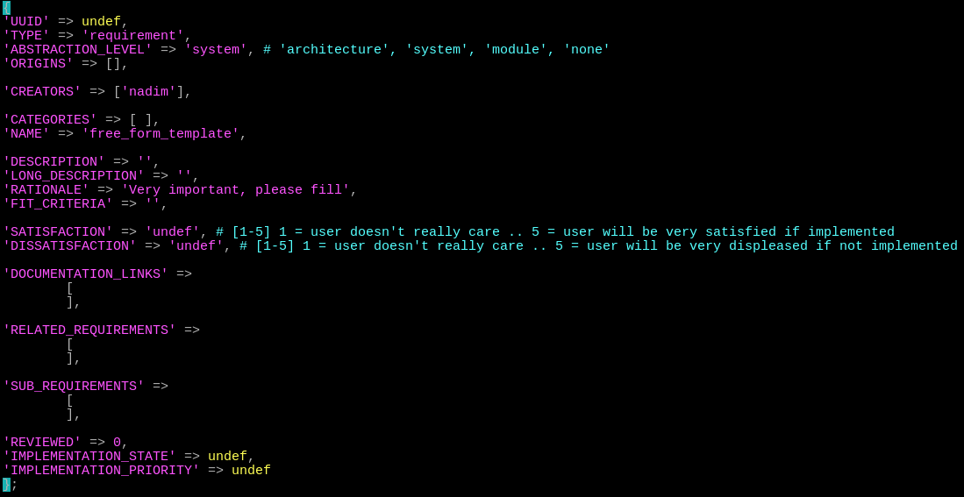
After using this application we found a lot of problems that we need to fix it, and ameliorate it “It’s hard to install it”. So we tried to solve the problems by making interviews with the client and also by asking some techniques and non-technical users and we found some solution. This project will explains the new version of the application.

2.2.3 Open source tools
- ReqSimile
ReqSimile is a Java application that operates on requirement sets.
Upon selection of a requirement in one requirement set, ReqSimile calculates the similarity to all the requirements in another requirements set “which could also be the same set in order for finding duplicates and other relations ships”.
It is like bringing intelligent search engine functionality to requirements management. The only difference is that you never start empty-handed and decide on a relevant query. The query is made up of the requirement you select[1]
ReqSimile may be used interactively to assign links between requirements. The links are stored in a separate database table and may represent any relationship you prefer depending on the requirements management process “e.g. same, duplicate, similar, related, etc.”.[2]
- The Minireq
The Minireq is a simple Command Line Interface “CLI” tool created for writing requirements in various Markdown files and building a general requirements document from these files “sort of GitBook[15]”. It also provides basic Domain Specific Languages[16] “DSL” for tracing requirement to other software projects artifacts, as well as software estimations by PERT[17].
The Minireq is simple enough in itself, but when you combine it with Ruby “through Rake or Thor”, a modern text editor “I use Atom[18]” and Git, this combination will bring you unprecedented power and flexibility in requirements management.[19]
- Comparative study of commercial software requirements tools
Tools /  Attributes | Glossary and ontology | Template | Use case modeling | Prototyping and audit | “TRS” | Scalability | External interface | Version control
RequisitePro
DOORS
Innoslate
Visure
Software functional requirements
Note: Means satisfies criterion
Means does not satisfy the criterion

2.3 scoping processing

2.3.1 Business process analysis
- Introduction
Business process analysis helps an organization improve how it conducts its functions and activities in order to reduce overall costs, provide more efficient use of scarce resources, and better support customers. It introduces the notion of process orientation, of concentrating on and re-thinking end-to-end activities that create value for customers, while removing unnecessary, non-value added work.
Generally technology is implemented to automate or streamline business processes, so it is important to conduct a business process analysis to understand how the process works and how it can be improved.
- Complete view of business process
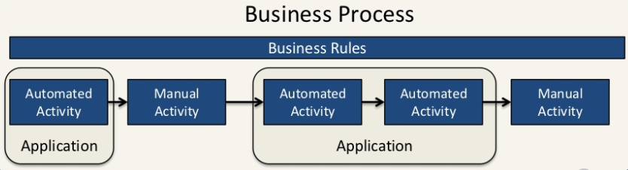
A process consists of a mix of automated and manual activities in a structured or ad-hoc manner to deliver expected outcomes.
Understanding the overall set of activities that comprise a process and their business rules is essential.
The requirements analyst needs to understand the entire picture to understand how a solution should operate. Systems/application generally only automate a part of the process.
Activities that are to be automated define the scope of the development and implementation work which may span multiple applications.
- Benefits
- Fewer overtime hours | - More stable work environment
- Improved working conditions | - Improved quality of work life
- Improved employee morale | - Reduced employee turnover
- Better company image | - Improved management of project risk

2.3.2 Functionality process analysis
- Introduction
Process analysis answers the question: “How?” Process analysis explains how the sequential steps of a procedure lead to its accomplishment; or, how a certain series of events occurred. There are two kinds of process analysis: directional and informational.
Directional, or prescriptive, process analysis asks: How do you do it? This kind of analysis examines how to do something in such a way that a process may be repeated. The analysis provides directions, as in the methods section of a laboratory report, or prescribes a certain process to follow.
Informational,or descriptive, process analysis asks: How does it work or occur? How is it done? This kind of analysis explains how something is, or was, accomplished. The analysis provides information, as in the outline of an organic process, or describes how “not why” certain events led to a particular outcome.

2.3.3 Business process analysis tools
“BPA” tools are primarily intended for use by business end users looking to document, analyze and streamline complex processes, thereby improving productivity, increasing quality, and becoming more agile and effective. These tools also support the roles of business process architect and business process analyst, and enable them to better understand business processes, events, work flows and data using proven modeling techniques.
“BPA” tools permit users to diagram their processes, noting “generally abstracted” rules or specifications to promote understanding, validate this information using standard methodologies and best practices enabled by the software, and ideally, automate the models into deployable applications that leverage their analytical efforts and comply with the business process rules. “BPA” tools feature the following functionality:
- Business model drawing and development | - Ease of use in operation, development and administration
- Business model analysis | - Multiuser support / versioning and extensibility
- Methodology and use | - Performance and scalability
- Integration and automation | - Vertical-industry and horizontal cross-industry template support

2.3.4 Technology analysis

2.3.5 Benefits analysis

2.4 Requirement management

2.4.1 Introduction
Requirements management is the process of collecting, analyzing, refining, and prioritizing product requirements and then planning for their delivery. The purpose of requirements management is to ensure that the organization validates and meets the needs of its customers and external and internal stakeholders.
Requirements management involves communication between the project team members and stakeholders, and adjustment to requirements changes throughout the course of the project. To prevent one class of requirements from overriding another, constant communication among members of the development team is critical.
Requirements management does not end with product release. From that point on, the data coming in about the application’s acceptability is gathered and fed into the Investigation phase of the next generation or release. Thus the process begins again.[11]
- Requirement presentation:
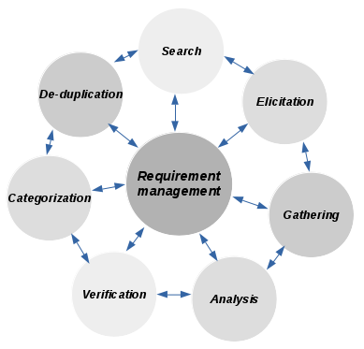
Requirements definition provides a solid foundation for the end product and provides the first view of what the intended product must do and clear descriptions of how it should perform. Requirements definition also provides a basis for design and seves as a foundation for testing and user acceptance of the end product. Requirements definition captures all levels of requirements and helps to ensure that the project meets its objectives within the agreed upon limitations of time, cost and functionality.[12]
Requirements definition is used to identify goals, needs, and objectives of the end product by asking questions like:
- What problem are we trying to solve?
- What do we need to do to solve the problem?
- How do we accomplish solving the problem?

2.4.2 Search
- Search form
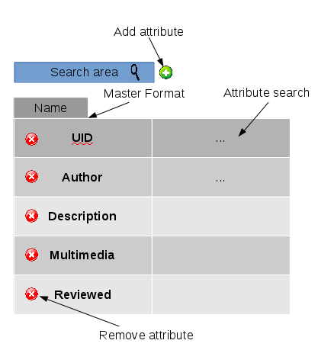
The search form attribute specifies a short hint that describes the expected value of an input field “simple value or a short description of the expected format”.
We created this template to help the non-technical user to better user our application, in this part the user can make easy search by adding or removing the attribute.
Master format is a standard specification of information for building projects.
The attribute search is designed to make requirement search.
- Continuous analysis
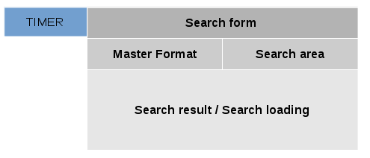
A continuous analysis allows the user to search for keywords and phrases across the major fields of the Master Format: UID, Author, Description, Multimedia, Reviewed, Satisfaction … .[20]
Unlike the other search options, the continuous search can find words and phrases within Master Format.
The continuous analysis finds all items in the catalog that include all of the search terms.
We can find the requirement search in the result area.
The continuous analysis called as the boolean search.
We can find too a timer calculates the search time.
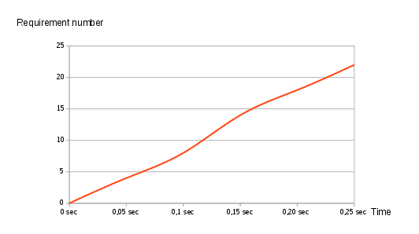

As we know the continuous search can make the way of search more easier, but when the number of requirements increase, the result will take more time to show the result of search.
The delay increases by roughly 0.011s per search result.
- Non-continuous search
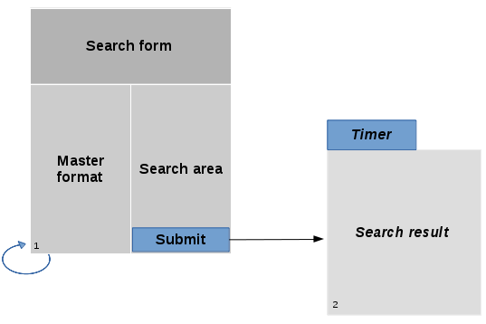
- Search
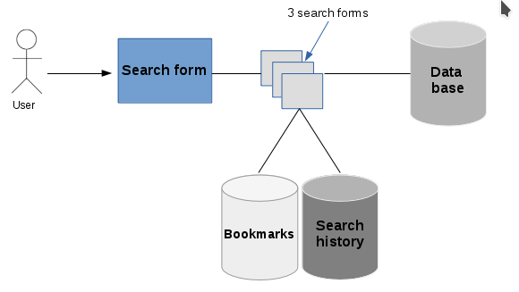
This part “Search” allows users to :
- Make the search in a easy way
- Access to the global database
- Access to the local database
- Save the best searches in the bookmarks
- Access to the local search database history
- Search history
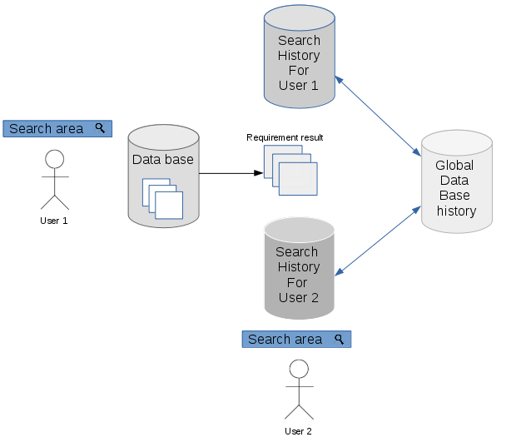
Search history allow users to :
- Retrieve queries
- Collaborate requirement result with other users
- Save history result of all users in a global database history search
- Presentation
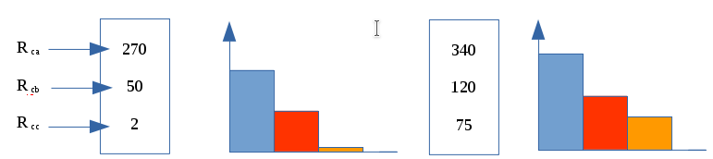

2.4.3 Elicitation
- Introduction
Requirements elicitation is the practice of collecting the requirements of a system from users, customers and other stakeholders. The practice is also sometimes referred to as “requirement gathering”.[21] The term elicitation is used in books and research to raise the fact that good requirements cannot just be collected from the customer, as would be indicated by the name requirements gathering. Requirements elicitation is non-trivial because you can never be sure you get all requirements from the user and customer by just asking them what the system should do OR NOT do “for Safety and Reliability”.[22] Requirements elicitation practices include “Brainstorming, Document analysis, Focus groups, Interface analysis, Interviews, Observation, Prototyping, Questionnaire”.[23]
- Brainstorming
  - Presentation
Process for generating creative ideas and solutions through intensive and freewheeling group discussion. Every participant is encouraged to think aloud and suggest as many ideas as possible, no matter seemingly how outlandish or bizarre. Analysis, discussion, or criticism of the aired ideas is allowed only when the brainstorming session is over and evaluation session begins.[24]
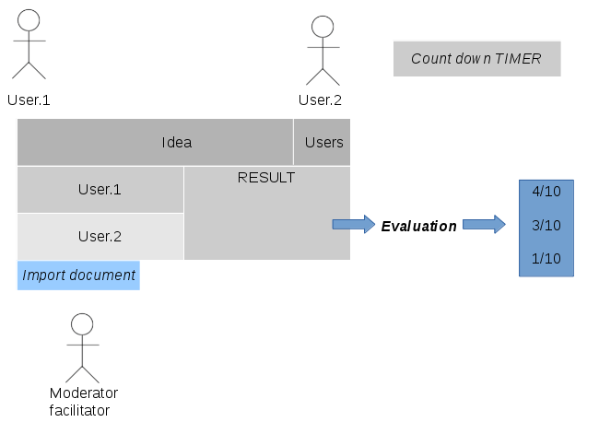
Brainstorming help engineer in the enterprise to:
- Collect more idea for the project
- Solve the problems
- Improve creative thinking
- Team work in a collaborative way
- The moderator collect the ideas and sorted it from important to less important “Evaluation”
- Virtual Brainstorming “Ex: Video conference”:
As we know the business world becomes more global, you may find yourself collaborating with colleagues and clients from all over the world.
Because of this, online meeting software has become a vital tool for businesses. With the right meeting technology, individuals can still stay connected no matter their geographic locations.[25]
- Document analysis
              - Presentation
The document analysis technique is one of the most effective ways of kick-starting the requirements elicitation phase. It is the art of studying relevant business, system and project documentation with the objective of understanding the business, the project background and identifying requirements or opportunities for improvement.
It’s a means of gathering information before scheduling interviews or other elicitation sessions with stakeholders. It can complement other elicitation techniques like workshops, interviews and prototyping by serving as a means of verifying requirements.[26]
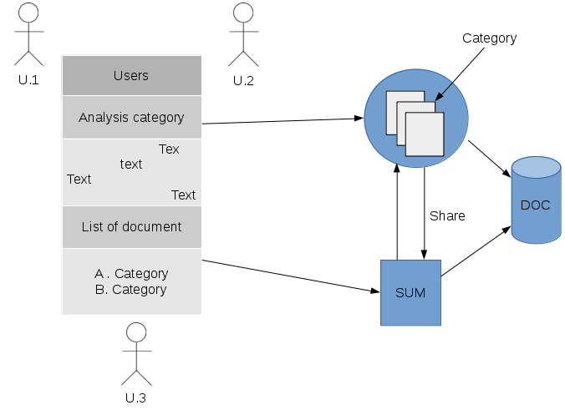
- Elicit information from existing documentation
- Implement the new ideas
- Make a goof business plan
- Use relevant documentation
- Share information between members “Emailing, Versionning ...”
- Save all the important informations in a Doc database
- classify requirement by categories
- Focus groups
  - Presentation
Focus group sessions are organized with the aim of gathering qualitative information from participants. They are a great way of achieving a deep understanding of the thoughts, attitudes and perceptions of participants on a range of topics. Focus groups can also help with identifying problems and issues related to a certain idea. As a result, adequate thought and planning should go into its preparation.
Focus groups offer a means of gathering information that is subjective by seeking answers to open-ended questions. Instead of distributing basic questionnaires that deliver data requiring further analysis, focus groups allow organizers to share their perspectives in a non-threatening, collaborative and interactive environment. Focus groups also provide a great platform for eliciting requirements and understanding stakeholders' perspectives on different issues.[27]
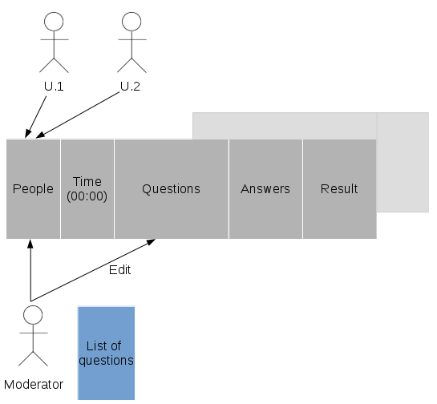
- Employ the principles of brainstorming
- Ensure the objectives of the group are clear
- The moderator/facilitator should present the questions in a way that triggers discussion and concisely enough to steer participants in the right direction
- Select participants carefully
- All questions and answers should saved in the template
- The moderator/facilitator write concluding analysis in the result part
- The result should reflecting on the major ideological themes of the group discussion
- The participants should respect the time of the meeting
- Interface analysis “components”
  - Presentation
An interface is a shared boundary between two components. Most systems require connections with other applications, hardware and peripheral devices to function properly. Interface Analysis is a business analysis elicitation technique that helps to identify interfaces between solutions/applications to determine the requirements for ensuring that the components interact with one another effectively.[28]
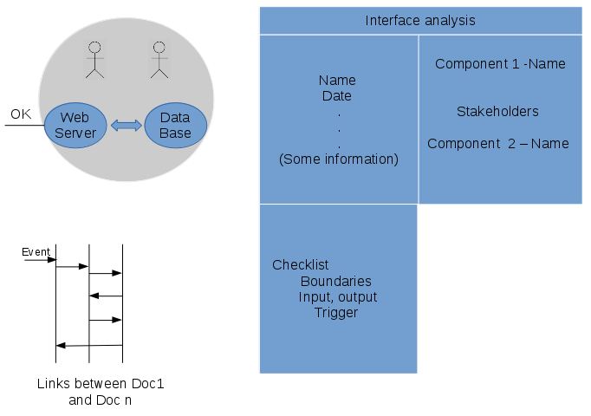
- Need prior understanding of project / application
- Interviews
  - Presentation
Interviews are one of the most popular business analysis techniques. They can be used to verify facts, clarify ambiguity, trigger enthusiasm, engage end users, identify requirements and solicit opinions and ideas.
BABOK V2[29] defines an interview as a systematic approach for eliciting information from a person “or a group of people” in an informal or formal setting by asking questions and documenting the responses.[30]

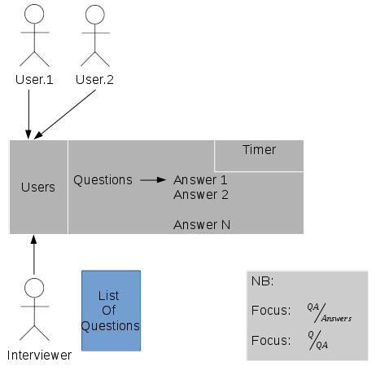
- The questions should be structured
- The questions should be wrote before the interview
- Focus must be “>1”, to say that it is a successful interviews
- The interview must be in a collaborative way, to collect more ideas about the project / application
- Observation
  - Presentation
Most people are used to observing events in their personal and professional lives. In some cases, we come to conclusions based on the events we observe. The observation technique is an effective means of deciphering how a user does their job by conducting an assessment of their work environment. It increases the analyst's familiarity with the culture and working style of a group of people. This technique can also be used to verify requirements and deliver instant requirements worthy of consideration.
Every observation must be guided by clearly stated objectives. The analyst should know what data is to be collected, how observation will be done, when and where to observe, how the data will be collected and what the data will be used for after analysis.
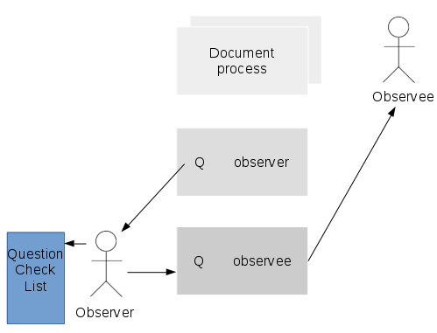
- The data gathered during observation sessions are quite reliable; it is often used to confirm the data extracted using other techniques
- Observation can be used to extract information on the physical environment where the task is performed. For example, the analyst can get information on level of noise, physical layout, traffic and so on
- It allows the analyst to perform work measurements
- Prototyping
  - Presentation
I once worked on a project that involved a series of discussions and consultations on whether to build or buy software. After extensive analysis, the decision was made to build the system in-house. To get started however, we had to prove that it could be done. We did this through a proof of concept “POC” / prototype.
A proof of concept “POC” / prototype is a demonstration aimed at verifying that certain concepts or theories can be achieved. A prototype is designed to determine feasibility, but does not represent the final deliverable.[31]
- Requirements workshops
  - Presentation
Involves analyzing the results of elicitation sessions and creating representations of those results. When that representation focuses on a solution, the outcome is known as “a design”.
This is where Design Thinking steps up. A Design Thinking approach enables Business Analysts to solve the wicked business problems they’ve always faced, but from a user-centric standpoint and following an iterative process. Design thinking is a way for BAs to create products that meet enterprise expectations by focusing on the right problems and finding the right solutions, all the while delivering products that users really love.
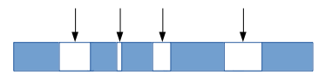
- Survey / Questionnaire
  - Presentation
The technique is an electronic or paper based approach of collecting needs from stakeholders. Questionnaires are distributed among stakeholders.
Questionnaires list all the questions relevant per a particular process. Questionnaires are good technique to gather requirements from remote locations.
Questionnaires are appropriate method to gather input from huge number of people.

2.4.4 Gathering
- Presentation
The “elicitation” step is where the requirements are first gathered from stakeholder.
Requirement gathering is often a challenging exercices as you need to work with stakeholders who have day jobs and competing demands. Often the business expect you to create the requirements but without the business input you will not create an end product which is flit for the business purposes.
So we need multiple techniques to gain a complete picture from a diverse set of clients and stakeholders.[39]
- One to One interviews
The most common technique for gathering requirements is to sit down with the stakeholder and ask them what they need.
The discussion should be planned out ahead of time based on the type of requirements you’re looking for.
There are many good ways to plan the interview, but generally you want to ask open-ended questions to get the interviewee to start talking and then ask probing questions to uncover requirements.
- Group interviews
Group interviews are similar to the one-on-one interviews, except that more than one person is being interviewed
These interviews work well when everyone is at the same level or has the same role.
Group interviews require more preparation and more formality to get the information you want from all the participants.
- Facilitated sessions
In a facilitated session, you bring a larger group “five or more” together for a common purpose.
In this case, you are trying to gather a set of common requirements from the group in a faster manner than if you were to interview each of them separately.
- Joint Application Development
“JAD” sessions are similar to general facilitated sessions.
However, the group typically stays in the session until the session objectives are completed.
- Questionnaires
Questionnaires are much more informal, and they are good tools to gather requirements from stakeholders in remote locations or those who will have only minor input into the overall requirements.
Questionnaires can also used when you have to gather input from dozens, hundreds, or thousands of people.
Ensure that you do not ask leading questions and ensure that you use open questions as far as possible.
- Prototyping
Prototyping is a relatively modern technique for gathering requirements.
You show this to the stakeholder, who then gives you additional requirements? You change the application and cycle around with the stakeholder again.
A downside of this methods is that you can end up forever changing the prototype and never progressing to a full system. To minimize this impact you should set clear time-line for prototyping and set clear expectations on the number of rounds you will conduct.
- Use cases
Use cases are basically stories that describe how discrete processes work.
The stories include people “actors” and describe how the solution works from a user perspective.
Use cases may be easier for the users to articulate, although the use cases may need to be distilled later into the more specific detailed requirements.
- Following people around
This technique is especially helpful when gathering information on current process.
You may find, for instance, that some people have their work routine down to such a habit that they have a hard time explaining what they do or why.
You may need to watch them perform their job before you can understand the entire picture.
In some cases, you might also want to participate in the actual work process to get a hand-on feel for how the business function works today.
- Brainstorming
On some projects, the requirements are not “uncovered” as much as they are “discovered”.
In other words, the solution is brand new and needs to be created as a set of ideas that people can agree to.
In this type of project, simple brainstorming may be the starting point.
The appropriate subject matter experts get into a room and start creatively brainstorming what the solution might look like.
He resulting consensus of best ideas is used for the initial requirements.

2.4.5 Analysis
- Presentation
Requirements analysis is critical to the success or failure of a systems or software project. The requirements should be documented, actionable, measurable, testable, traceable, related to identified business needs or opportunities, and defined to a level of detail sufficient for system design.[36]
- Characteristics of a good requirement
Cohesive: The requirement defines a single aspect of the desired business process or system.
Complete: The individual requirement is not missing necessary or relevant information. Additionally, the entire set of requirements should cover all relevant requirements.
Consistent: The requirement does not contradict another requirement.
Modifiable: Like requirements should be grouped together to allow similar requirements to be modified together in order to maintain consistency.
Correct: The requirement meets the actual business or system need. An incorrect requirement can still be implemented resulting in a business process or system that does not meet the business needs.
Observable: The requirement defines an aspect of the system that can be noticed or observed by a user. This is often referred to as “Implementation Agnostic” as the requirement should not specify aspects of system architecture, physical design or implementation decisions.
Feasible: The requirement can be implemented within the constraints of the project including the agreed upon system architecture or other physical design or implementation decisions.
Unambiguous: The requirement is written objectively such that there is only a single interpretation of the meaning of the requirement.
Verifiable: It can be shown that the requirement has been met by the final solution via inspection, demonstration, test, or analysis.[37,38]

2.4.6 Validation / Verification
- Definitions
  - Validation
The process of determining whether or not the products of a given phase of the software development cycle fulfill the requirements established during the previous phase.
  - Verification
The process of evaluating software at the end of the software development process to ensure compliance with software requirements.[32]
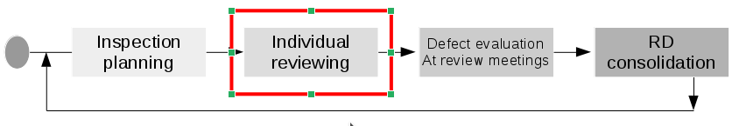
- Verification / Validation accepted method
  - Test
  - Analysis
  - Demonstration
  - Inspection

2.4.7 Categorization
- Definition
A category set is a related set of categories which may be applicable to requirements. A category set is used to organize requirements according to a classification scheme which is specific to that category set.
- Why categorize requirements?
  - Organizing the presentation of requirements according to different viewpoints, and the needs of different audiences.
  - Determining the requirements applicable to different aspects of development. For example,safety requirements need special assurance activities, while reliability requirements can be important drivers of certain aspects of the design.
  - Viewing or reporting requirements according to categories to assess relationships between associated requirements, to identify conflicts and overlaps, or to assess completeness and/or consistency.
  - Planning, modeling and managing requirements-related activities.

2.4.8 De-duplication

2.5 Collaboration

2.6 User right management

2.7 Version control
- Definition
Version control “also known as revision control or source control” is a category of processes and tools designed to keep track of multiple different versions of software, content, documents, websites and other information in development. Any system that provides change tracking and control over programming source code and documentation can be considered version control software. The practice has been a part of creative processes almost as long as writing has existed.[34]
- Purpose
The purpose of version control is ensuring that content changes under development go as planned. While version control is often carried out by a separate application, it can also be embedded into programs such as integrated development environments “IDEs”, word processors, spreadsheets and, especially, collaborative web documents and pages. Version control allows servers in multiple locations to run different versions on different sites, even while those versions are being updated simultaneously.[35]
- GIT
  - Definition
Git is a free and open source distributed version control system designed to handle everything from small to very large projects with speed and efficiency.
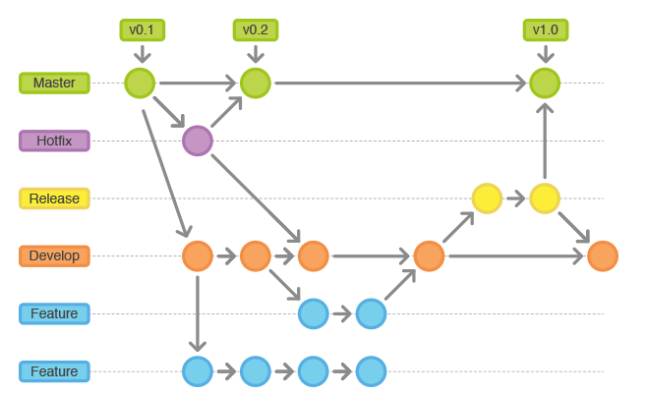
- Github
  - Definition
GitHub is a web-based Git or version control repository and Internet hosting service. It offers all of the distributed version control and source code management (SCM) functionality of Git as well as adding its own features. It provides access control and several collaboration features such as bug tracking, feature requests and task management.
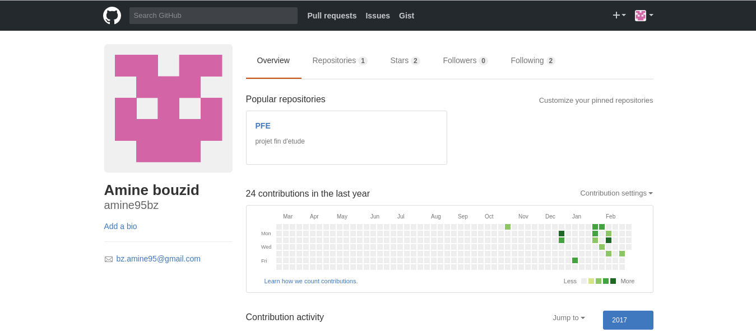

2.8 Visualization

2.9 Synchronization UI-s

3 Design

3.1 Concept

3.1.1 Introduction

3.1.2 On-line work

3.1.3 Off-line work

3.1.4 Conclusion

3.2 Use cases

3.3 Data base format/Entry form

3.4 Setting up

3.4.1 Users

3.4.2 Crowd sourcing

3.4.3 Development environment

3.5 Data structure

4 Development

4.1 Use languages

4.2 NodeJS
- Presentation
Node.js is an open-source, cross-platform JavaScript runtime environment for developing a diverse variety of server tools and applications. Although Node.js is not a JavaScript framework, many of its basic modules are written in JavaScript, and developers can write new modules in JavaScript. The runtime environment interprets JavaScript using Google's V8 JavaScript engine.
Node.js has an event-driven architecture capable of asynchronous I/O. These design choices aim to optimize throughput and scalability in Web applications with many input/output operations, as well as for real-time Web applications “real-time communication programs and browser games”.
The Node.js distributed development project, governed by the Node.js Foundation, is facilitated by the Linux Foundation's Collaborative Projects program

4.3 Html5
- Presentation
HTML5, is a markup language used for structuring and presenting content on the World Wide Web. It is the fifth and current version of the HTML standard.
It was published in October 2014 by the World Wide Web Consortium (W3C)[2][4] to improve the language with support for the latest multimedia, while keeping it both easily readable by humans and consistently understood by computers and devices such as web browsers, parsers, etc. HTML5 is intended to subsume not only HTML 4, but also XHTML 1 and DOM Level 2 HTML.[5]
HTML5 includes detailed processing models to encourage more interoperable implementations; it extends, improves and rationalizes the markup available for documents, and introduces markup and application programming interfaces (APIs) for complex web applications.[6] For the same reasons, HTML5 is also a candidate for cross-platform mobile applications, because it includes features designed with low-powered devices in mind.

4.4 jQuery
References
- ReqSmile: http://reqsimile.sourceforge.net/
- ReqSmile: https://sourceforge.net/projects/reqsimile/?source=typ_redirect
- DOORS: doc, Tools for Requirements Management: a Comparison of Telelogic DOORS and the HV Tony Cant, Jim McCarthy and Robyn Stanley Information Networks Division Defence Science and Technology Organization.
- DOORS: http://www-03.ibm.com/software/products/en/ratidoor
- Innoslate: https://www.innoslate.com/solutions/
- Requisite Pro “IBM”: https://www.ibm.com/support/knowledgecenter/SSSHCT_7.1.0/com.ibm.reqpro.help/get_start/c_product_overview.html
- Open source: https://opensource.com/
- Open source https://fr.wikipedia.org/wiki/Open_source
- Closed source: https://en.wikipedia.org/wiki/Proprietary_software
- The agile movement: http://agilemethodology.org/
- The agile movement: https://fr.wikipedia.org/wiki/M%C3%A9thode_agile
- Requirement management: Computer Supported Cooperative Work in Design, 2007. CSCWD 2007. 11th International Conference on
- Requirements: https://www2.cdc.gov/cdcup/library/practices_guides/CDC_UP_Requirements_Management_Practices_Guide.pdf
- Visure: http://www.visuresolutions.com/
- GitBook: https://help.gitbook.com/basics/what-is-gitbook.html
- Domain specific language: https://en.wikipedia.org/wiki/Domain-specific_language
- PERT: http://searchsoftwarequality.techtarget.com/definition/PERT-chart
- Atom: https://atom.io/
- The MinReq: https://github.com/nvoynov/minireq
- Dartmouth College Library, Hanover, NH, USA 03755 web site http://www.dartmouth.edu/~library/home/help/libcat/keyword.html?mswitch-redir=classic
- Elicitation: https://en.wikipedia.org/wiki/Requirements_elicitation
- Elicitation: http://fr.slideshare.net/vivacemente/requirement-elicitation
- Elicitation: http://fr.slideshare.net/PeteFrey1/10-requirement-elicitation-techniques-for-b-as
- Brainstorming: http://www.brainstorming.co.uk/tutorials/whatisbrainstorming.html
- virtual brainstorming: https://www.pgi.com/blog/2013/08/seven-ways-to-get-great-ideas-out-of-a-virtual-brainstorming-session/
- Document analysis: https://businessanalystlearnings.com/ba-techniques/2013/5/17/understanding-the-document-analysis-technique
- Focus groups: Guidebook Series - A Beginner's Guide To Requirements Elicitation: What To Do Before, During & After The Event, site web: https://businessanalystlearnings.com
- Interface analysis: https://businessanalystlearnings.com/ba-techniques/2014/5/31/interface-analysis
- BABOK V2: http://www.slideshare.net/carlitos5071989/babok-v20
- Interviews: https://businessanalystlearnings.com/ba-techniques/2013/7/18/interviews-requirements-elicitation-technique
- Prototyping: https://businessanalystlearnings.com/blog/2013/9/1/proof-of-concept-benefits-risks-of-prototyping-in-business-analysis?rq=prototyping%20analysis
- Verification & validation: software requirements and design specifications. Boehm, B W IEEE Software. Vol. 1, no. 1, pp. 75-88. 1984
- Categorization:
- Version control: https://techterms.com/definition/version_control
- Version control: https://www.git-tower.com/learn/git/ebook/en/desktop-gui/basics/why-use-version-control
- Req analysis: https://en.wikipedia.org/wiki/Requirements_analysis
- characteristic: http://www.modernanalyst.com/Careers/InterviewQuestions/tabid/128/ID/1169/What-are-the-characteristics-of-a-good-requirement.aspx
- characteristic: http://www.informit.com/articles/article.aspx?p=1152528&seqNum=4
- Gathering: https://www.projectsmart.co.uk/requirements-gathering.php

Term_definitions

